Sulphur Springs ISD Family Access FAQs and Navigation Cheat Sheet

The following document will walk through frequently asked questions regarding the use and management of Family Access. Family Access allows parents or guardians to view grades, check schedules, send and receive messages, register students, and much more.

1. What is Family Access?

Family Access is an electronic resource made available to every family of a student attending SSISD. This resource provides real-time information about your child's grades, attendance, class schedule, demographic information, and more. Family Access provides safe, secure, and easy access to your child's school record through a web portal linked through the district website.

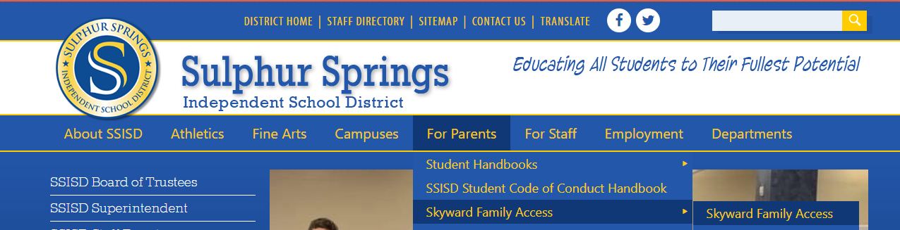

2. How do I sign up for Family Access?

Parents or guardians with existing students at SSISD should already have an account created for their children who attend. New parents or guardians to the district will have an account auto-created upon submitting an application that is approved using the district’s NEW to District Enrollment process. The account access information is linked through the email address used when submitting a new application and contains a link for access, a username, and a password. If you need assistance with your account, please contact your child’s school of enrollment.

3. Will I need to sign up for Family Access every school year?

No – once you have an active account, you do not need to re-apply for access. If you need assistance with your account, please contact your child’s school of enrollment.

4. Why do my spouse and I need different Family Access accounts?

Each parent or guardian has his or own unique login and password established. Individual accounts are used as long as each parent or guardian has legal rights to obtain information about the student. This will be verified when the account is being processed.

5. Can I see information on my students that attend different campuses? Do I need a separate account for each child?

You will be able to see information about each of your children that attend other campuses by using a drop-down to toggle between them. Each parent or guardian will have one account that provides access to each of your children attending at the district.

6. How do I change my password?

To change your password, you need to login to Family Access. Once you are at the main display for Family Access, select the My Account link in the upper-right corner of your screen. The screen will display your personal Account Settings, including a button to Change Password. You will be required to provide your current password before updating or changing to a new password.
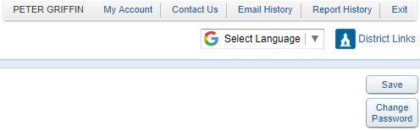
7. How can I recover my password if I forget it?

Navigate to the Family Access login page and click on the “Forgot your Login/Password” link.

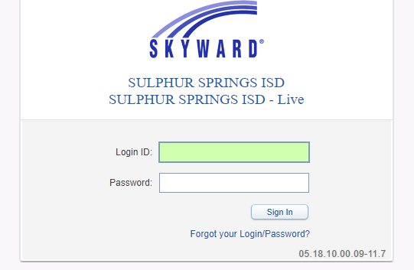

Proceed to enter your Email or User Name (if you know it). Select the Submit button and you will receive an email with your username and a link for your password. Please follow the directions in the email to reset your password. If you need additional assistance, please contact your child’s school of enrollment.

8. Why aren’t all of my student’s grades available at the same time? How often are student grades updated?

Family Access provides real-time information regarding your child’s grades. Grade reporting is a campus/department decision. Since teachers input grades over a period of time, not all grades will show up at the same time. Questions regarding grades should be directed to your child’s teacher. Questions regarding report cards and grade posting should be directed to your child’s school of enrollment.

9. Who do I contact regarding questions about Family Access?

You may find it helpful to contact another parent or guardian that has a child attending the district with questions about Family Access. If you do not have a parent contact to reach, please contact your child’s school of enrollment. To access a list of campuses and contact options, please click here. A video tutorial is also available by clicking here.

Basic Navigation Options for Family Access

The following document will walk through basic navigation and options available to parents using Family Access portal. It allows parents to view messages and communicate with teachers and staff, register returning students, enroll new children, view grades, and much more.

10. Upon logging into the Family Access portal, parents will see a “wall” or main page that displays a variety of information, including messages from teachers and school or district staff.

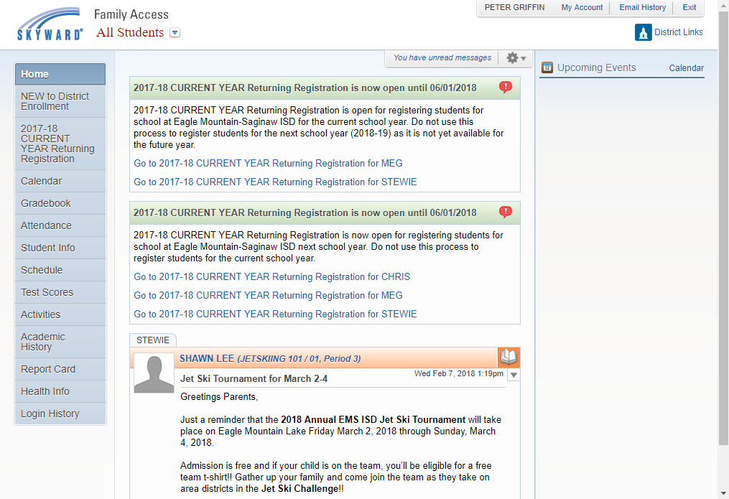

11. Utilize the drop-down in the upper-left to toggle between different students enrolled.

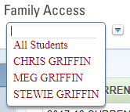

12. The tabs along the left of the screen allow parents to toggle between different areas to view information for a selected student. It’s important to understand what the different tab options have to offer.
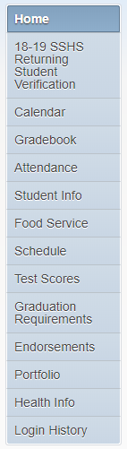
The Home button will allow a parent to navigate back to the main screen.

NEXT YEAR Returning Verification is available in the Spring for currently enrolled students or students who left and are returning for the future school year.

Online Forms allows access to optional registration forms or other district forms.

The Calendar option shows calendar details, assignment details, and more.

Select the Gradebook tab to view student grades, assignment scores, and to drill down to view assignment details, percentages, and comments.

The Attendance tab provides details on your child’s attendance.

Student Info displays your child’s details saved within our student management system.

Food Service tab links you to the Lunch Money Now website.

The Schedule tab allow you to view your child’s schedule and teachers.

Access the Test Scores tab to view standardized test scores.

Graduation Requirements provides a generic transcript of sorts, showing a snapshot of grade history for your child’s enrollment over the years.

Endorsements shows the progress of your students Endorsement.

The Portfolio tab displays copies of your child’s report cards, transcripts, STAAR Score sheets in the event the school shares them online.

Health Info shows your child’s vaccination records as saved with the district.

Login History provides a snapshot of your login history to the Family Access portal.

13. Utilize the My Account link in the upper-right to view or update options associated to your personal information. This includes options to enable Email Notifications, Change Password, and trigger the Show Google Translator in Family Access option for viewing in different languages.

14. Online Forms provides access to electronic forms shared by the district. This option allows a parent to complete and submit a form electronically to save time and paper. Some of these forms, such as a student transfer form may also appear with a link on a parent or guardians Family Access wall.

